29
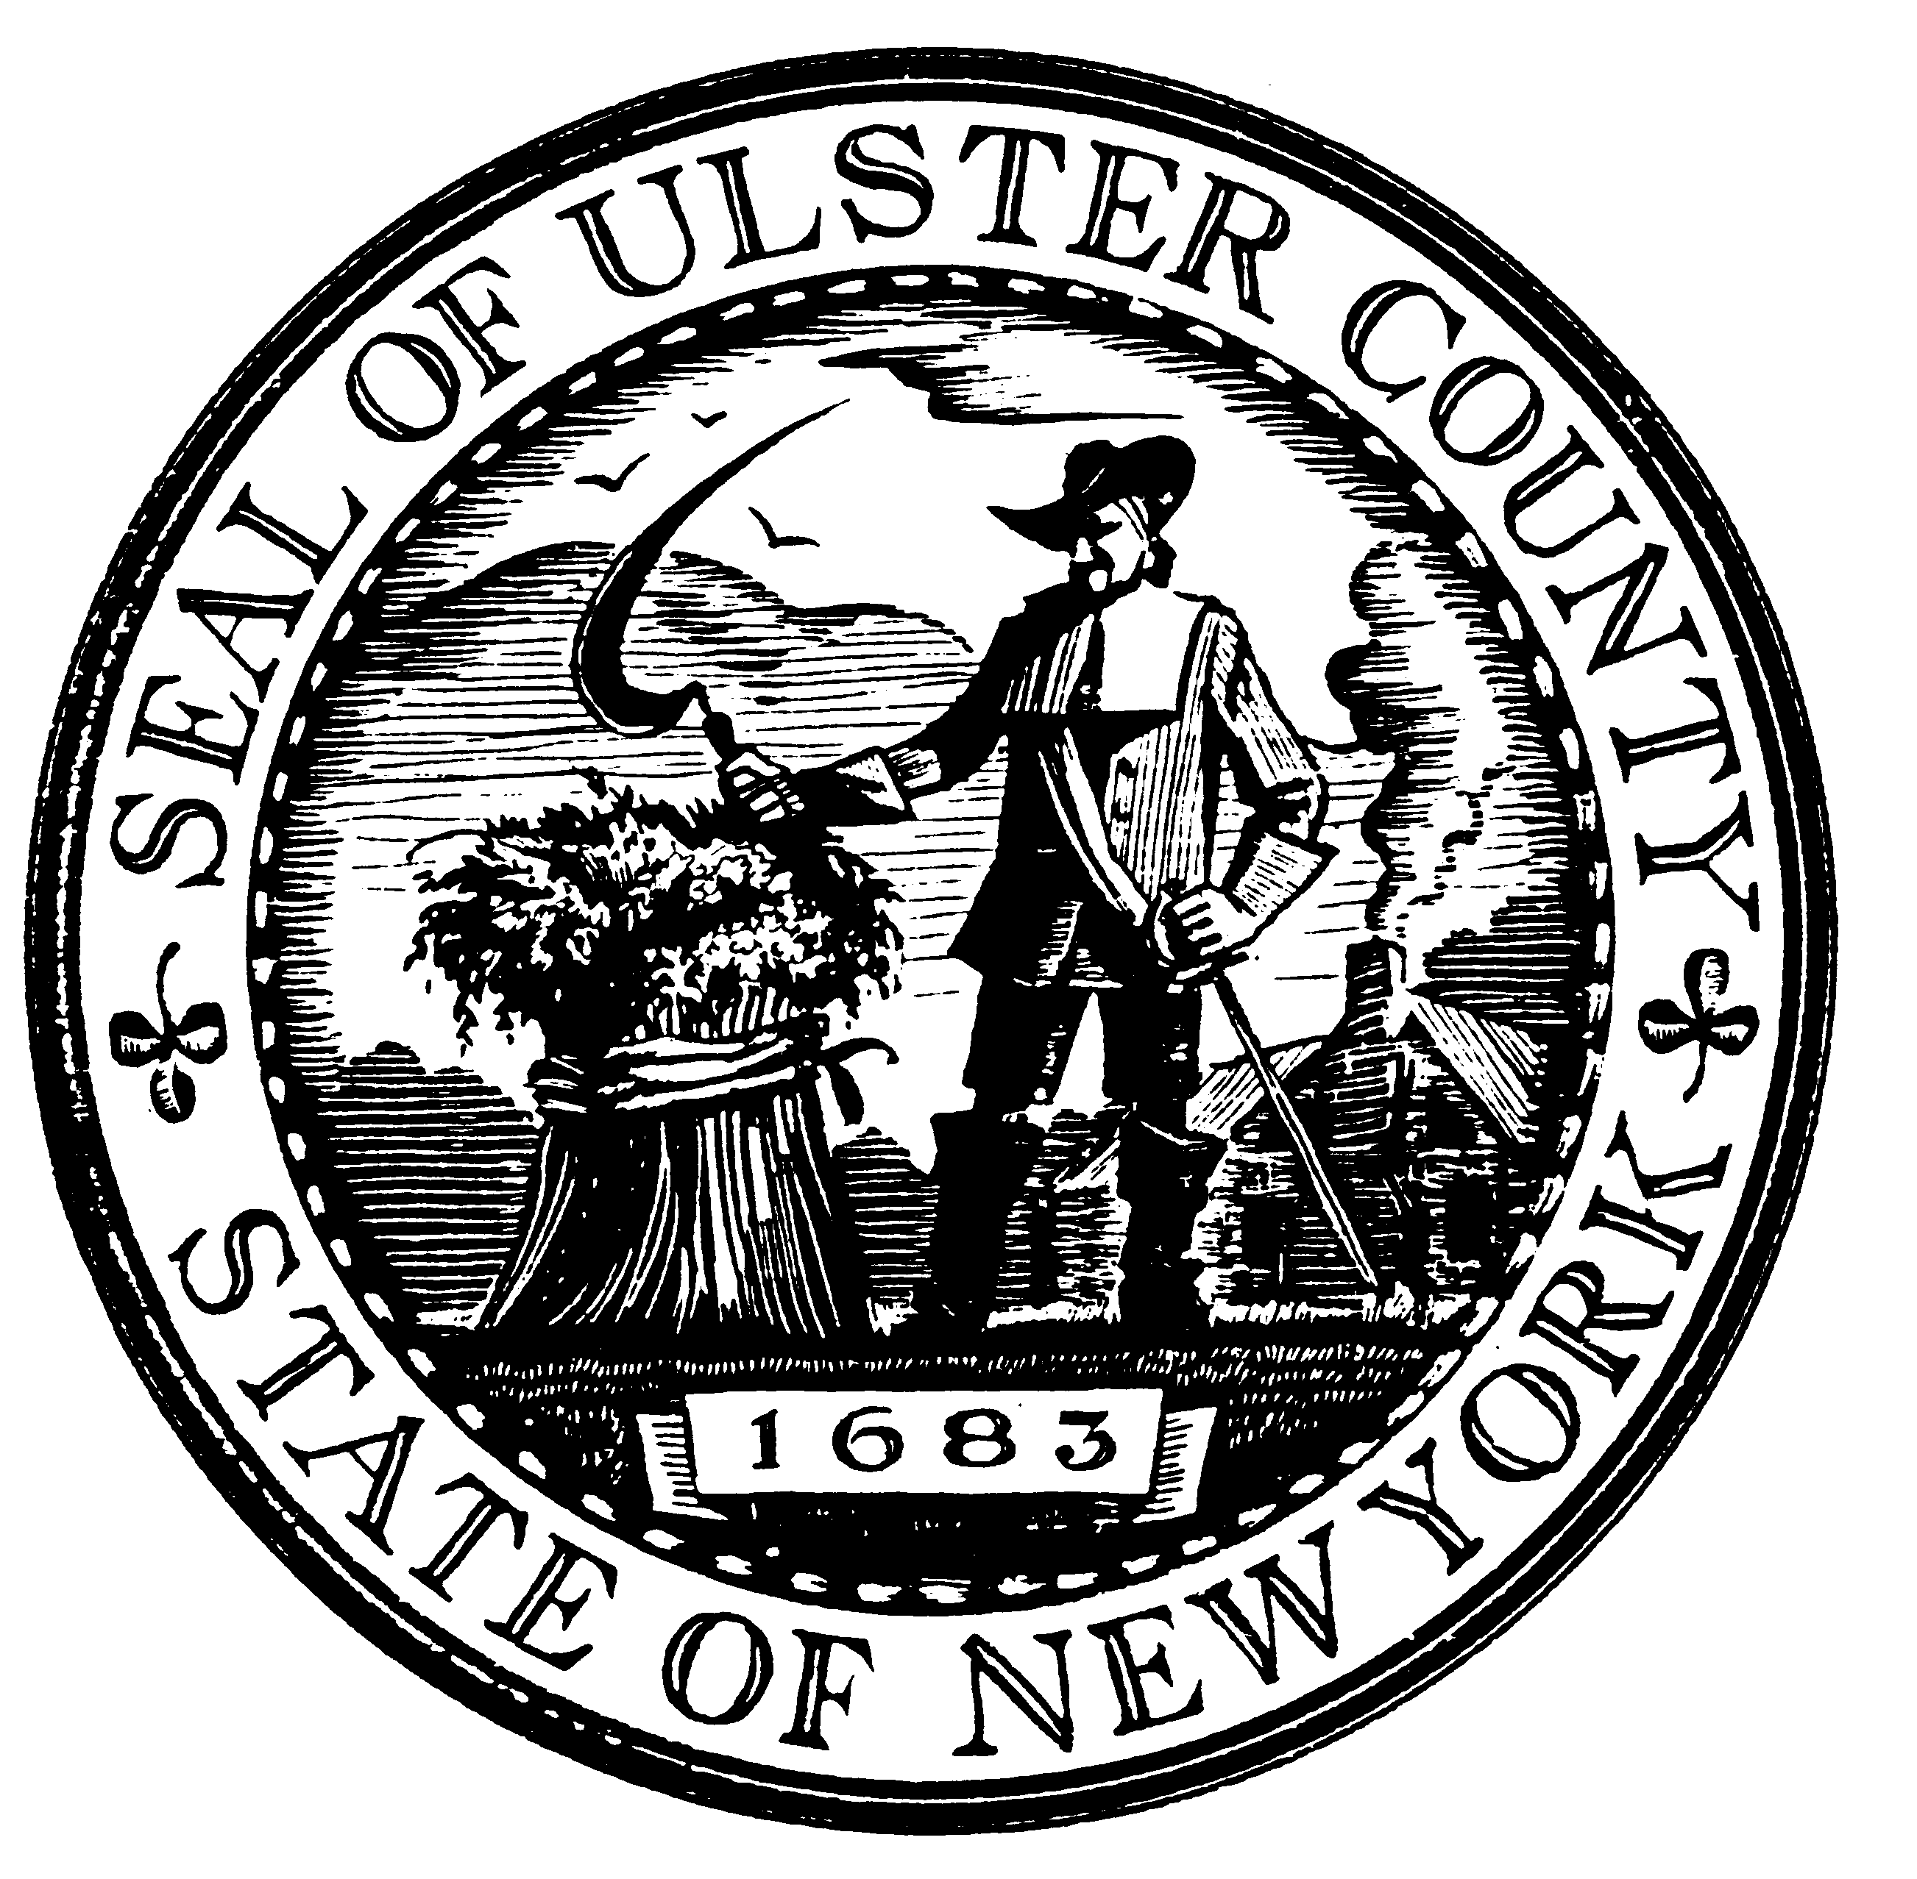 ULSTER COUNTY NEWS

ULSTER COUNTY NEWS INFORMATION 845.340.3900
OFFICE OF ULSTER COUNTY LEGISLATURE FAX: 845.340.3651
244 FAIR STREET www.co.ulster.ny.us
KINGSTON, NEW YORK 12401 www.ulstercountyny.gov

Weekly Update For The Week Of
March 10 – March 14, 2014
-UPDATED/REVISED-
Monday, March 10 | 5:00 PM – Community Services Board, Rooms 300/303, 239 Golden Hill Lane, Kingston  6:15 PM – Public Health & Social Services Committee, Karen L. Binder Library, 6th Floor, COB
Tuesday, March 11 | No Meetings
Wednesday, March 12 | 8:00 AM – Ulster County Industrial Development Agency Board of Directors, Karen L. Binder Library, 6th Floor, COB  5:00 PM – Ways & Means Committee, Karen L. Binder Library, 6th Floor, COB  5:15 PM – People with Developmental Disabilities Subcommittee of the Community Services Board, Rooms 300/303, 239 Golden Hill Lane, Kingston  6:00 PM – Caucus: Democrats - Karen L. Binder Library, 6th Floor; Republicans - Surrogates Court, 3rd Floor, COB  Immediately Following Caucus: Law Enforcement & Public Safety Committee, Karen L. Binder Library, 6th Floor, COB
Thursday, March 13 | No Meetings
Friday, March 14 | No Meetings

